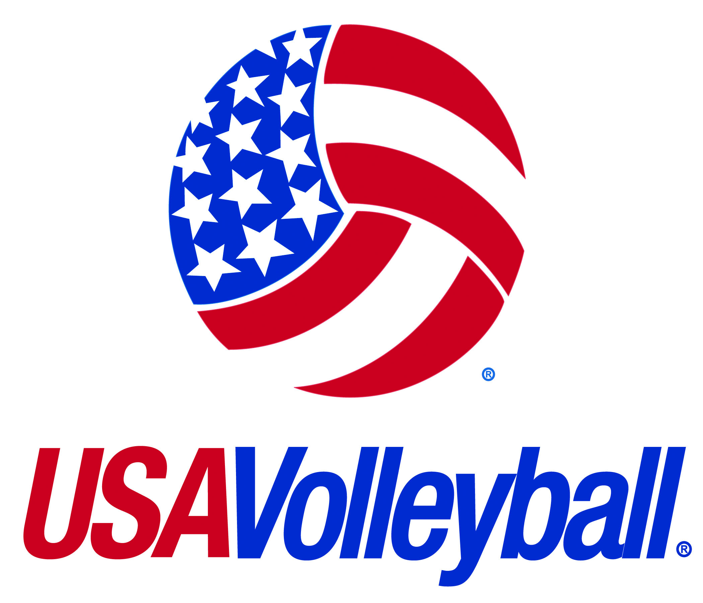 | USA VOLLEYBALL - 2011-2012 INDIVIDUAL MEMBERSHIP FORM
. | This application, the USAV Code of Conduct and Waiver and Release of Liability must be read and signed before the USAV registrant/RVA member listed on the application is allowed to take part in any training, competition, practice/warm-up sessions, and meeting or testing sessions. Additional RVA requirements may apply.
MEMBERSHIP APPLICATION
LEGAL FIRST NAME: |  |  |  |  |  |  |  |  |  |  |  |  |  |  |  |  |  | MI: |  |  |  |  |  |  |  | LEGAL LAST NAME:
Check box if name has changed in the past year. If yes, please provide previous name:
ADDRESS:
CITY: |  |  |  |  |  |  |  |  |  |  |  |  |  |  |  |  | STATE: |  |  |  |  |  |  |  |  | ZIP CODE: |  |  |  |  |  |  |  |  | BIRTHDATE:
GENDER: |  |  | Male |  |  |  |  |  |  | Female |  |  |  |  |  |  |  |  |  |  | E-MAIL:
JUNIORS ONLY: |  |  |  |  |  |  |  |  |  |  |  |  |  |  |  |  |  |  |  |  |  |  |  | (USA Volleyball does NOT provide e-mail addresses to third parties)
GRADE (2011/12 School Year) |  |  |  |  |  |  |  |  |  |  |  |  |  |  |  |  |  |  |  |  |  |  |  | HOME PHONE:
HIGH SCHOOL GRAD YEAR |  |  |  |  |  |  |  |  |  |  |  |  |  |  |  |  |  |  |  |  |  |  |  | CELL PHONE:
SCHOOL NAME: |  |  |  |  |  |  |  |  |  |  |  |  |  |  |  |  |  |  |  |  |  |  |  | WORK PHONE:
Check box if you do NOT wish to be on USAV master 3rd party list. |  |  |  |  |  |  |  |  |  |  |  |  |  |  |  |  |  |  |  |  |  | Check box if you do NOT wish to receive USAV electronic news.
USA Volleyball is committed to diversity. This information is used to report aggregate data to the United States Olympic Committee. Please check one of the following:
I choose not to respond |  |  |  |  |  |  |  |  |  |  |  |  |  |  |  |  |  |  |  |  |  |  | White, not Hispanic or Latino
American Indian or Alaskan Native, not Hispanic or Latino |  |  |  |  |  |  |  |  |  |  |  |  |  |  |  |  |  |  |  |  |  |  | Asian, not Hispanic or Latino
Black or African American, not Hispanic or Latino |  |  |  |  |  |  |  |  |  |  |  |  |  |  |  |  |  |  |  |  |  |  | Hispanic or Latino
Two or more races, not Hispanic or Latino |  |  |  |  |  |  |  |  |  |  |  |  |  |  |  |  |  |  |  |  |  |  | Native Hawaiian or Other Pacific Islander, not Hispanic or Latino
Are you:
Hearing impaired/deaf (for USA Deaflympic Talent ID) |  |  |  |  |  |  |  |  |  |  |  |  |  |  |  |  |  |  |  |  |  |  | Disabled Physically (for Paralympic Talent ID)
Membership Options (Annual fees per person)
 |  |  |  |  |  |  |  |  |  |  |  |  |  |  | $ |  |  |  |  |  |  |  |  |  |  |  |  |  |  |  |  |  |  |  |  |  | $
 |  |  |  |  |  |  |  |  |  |  |  |  |  |  | $ |  |  |  |  |  |  |  |  |  |  |  |  |  |  |  |  |  |  |  |  |  | $
 |  |  |  |  |  |  |  |  |  |  |  |  |  |  | $ |  |  |  |  |  |  |  |  |  |  |  |  |  |  |  |  |  |  |  |  |  | $
 |  |  |  |  |  |  |  |  |  |  |  |  |  |  | $ |  |  |  |  |  |  |  |  |  |  |  |  |  |  |  |  |  |  |  |  |  | $
Extended Officials Insurance |  |  |  |  |  |  |  |  |  |  |  |  |  |  | $ | 6.85 |  |  |  |  |  |  | Optional Donation to USA Team Programs. * |  |  |  |  |  |  |  |  |  |  |  |  |  | $ |  | 5.00
*$1 will be donated to each: Men’s and Women’s National Teams, High Performance Girls and Boys and Regional Junior Development
Participant Role(s)
(Check all that apply – Depending on selection, additional requirements may apply)
Player |  | Head Coach |  |  |  |  | Assistant Coach |  |  |  |  |  |  |  |  | Team Rep |  |  |  | Chaperone |  |  |  |  |  |  |  |  |  |  | Official |  |  | Other ___________________
ACKNOWLEDGEMENT/USE AGREEMENT
- I agree that I will abide by the rules and guidelines regarding club affiliation as established by the Regional Volleyball Association in which I am applying for membership.
- I hereby agree to be filmed, videotaped and photographed, and to have my name, image, picture, likeness, voice and biographical information otherwise recorded, in any media, during USA Volleyball (USAV) and/or its Regional Volleyball Association (RVA) sanctioned events, by USAV/RVA’s authorized representative, under the conditions specified by the USAV/RVA (the “Footage”).
- I hereby grant USAV/RVA, with no financial or other compensation due to me, full right and license to use, and to authorize third parties to use, in all media, the Footage for: (1) news and information purposes, (2) promotion of the specific competition(s) in which I compete, (3) promotion of the Sport, and (4) promotion of USAV/RVA, provided that, in no event may the USAV/RVA use or authorize the commercial use of the Footage in any manner that would imply my endorsement of any company, product, or service, without my written permission.
SIGNATURE REQUIRED
- I hereby certify that the information provided is being done directly by myself or by me, as the legal guardian representing a minor, and that it is true and accurate to the best of my knowledge. I also understand and agree that false information is grounds for denial of membership.
Participant’s Signature (regardless of age): |  |  |  |  |  |  |  |  |  |  |  |  |  |  |  |  |  |  |  |  |  |  |  |  |  |  |  |  |  |  |  |  |  |  |  | Date signed:
If applicant is under 18 years of age
Parent/Guardian’s Name |  |  |  |  |  |  |  |  |  |  |  |  |  |  |  |  |  |  |  |  |  |  |  |  | E-Mail:
Parent/Guardian’s Signature: |  |  |  |  |  |  |  |  |  |  |  |  |  |  |  |  |  |  |  |  |  |  |  |  |  |  |  |  |  |  |  |  |  |  |  | Date signed:
USA VOLLEYBALL WAIVER AND RELEASE OF LIABILITY
I acknowledge that volleyball or any sporting event is an extreme test of a person’s physical and mental limits and that my participation in a volleyball event can cause potential death, serious injury, or property damage. With a full understanding of the potential risks, I HEREBY ASSUME THE RISKS OF PARTICIPATING OR OFFICIATING IN A VOLLEYBALL EVENT.
I hereby take the following action for myself, my executors, administrators, heirs, next of kin, successors and assigns: a) I WAIVE, RELEASE, AND DISCHARGE from any and all claims or liabilities for death or personal injury or damages of any kind, EXCEPT THAT WHICH IS THE RESULT OF GROSS NEGLIGENCE AND/OR WANTON MISCONDUCT OF PERSONS OR ENTITIES LISTED BELOW, which arise out of or relate to my traveling to and from or my participation in any volleyball event, THE FOLLOWING PERSONS OR ENTITIES: USA Volleyball and its Regional Volleyball Associations, tournament directors, sponsors, and the officers, directors, employees, representatives, and agents of any of the above; b) I AGREE NOT TO SUE any of the persons or entities listed above for any of the claims or liabilities that I have waived, released or discharged herein; and c) I INDEMNIFY AND HOLD HARMLESS the persons or entities mentioned above from any claims made or liabilities assessed against them as a result of my actions.
Participant’s Signature (regardless of age):  SIGNATURE REQUIRED |  |  |  |  |  |  |  |  |  |  |  |  |  |  |  |  |  |  |  |  |  |  |  |  |  |  |  |  |  |  |  |  |  |  |  | Date signed:
If applicant is under 18 years of age, a parent or guardian must execute, in addition to the foregoing Waiver and Release, the following, for and on behalf of the minor.
The undersigned parent and natural guardian or legal guardian of the applicant ( ______________________________________________ [minor’s name]) executes the foregoing Waiver and Release for and on behalf of the minor named herein. I hereby bind myself, the minor and all other assigns to the terms of the Waiver and Release. I represent that I have legal capacity and authority to act for and on behalf of the minor named herein, and I agree to indemnify and hold harmless the persons or entities named in the Waiver and Release for any claims or liabilities assessed against them as a result of any insufficiency of my legal capacity or authority to act for and on behalf of the minor in the execution of the Waiver and Release. I fully consent to my child’s participation in USAV/RVA events.
Parent/Guardian’s Name (if registrant is under 18 years of age):
Parent/Guardian’s Signature: |  |  |  |  |  |  |  |  |  |  |  |  |  |  |  |  |  |  |  |  |  |  |  |  |  |  |  |  |  |  |  |  |  |  |  | Date signed:
USA VOLLEYBALL CODE OF CONDUCT
THE FOLLOWING ACTIONS ARE PROHIBITED:
- Violation of any anti-doping policies, protocols or procedures as defined by the International Olympic Committee (IOC), World Anti-Doping Agency (WADA), Federation Internationale de Volleyball (FIVB), US Anti-Doping Agency (USADA) or the United States Olympic Committee (USOC). Violations of this provision will be adjudicated only by USADA or the proper anti-doping authority, not USA Volleyball (USAV).
- Possession, consumption or distribution of alcohol and/or tobacco if illegal or in violation of USA Volleyball (USAV) or Regional Volleyball Association (RVA) policy.
- USAV policy prohibits the possession, consumption or distribution of alcohol and/or tobacco by anyone registered as a junior volleyball player at the event venue of any USAV/RVA sanctioned junior event.
- Use of a recognized identification card by anyone other than the individual described on the card.
- Physical damage to a facility or theft of items from a room, dormitory, residence or other person. (Restitution will be part of any penalty imposed.)
- Possession of fireworks, ammunition, firearms, or other weapons or any item or material which by commonly accepted practices and principles would be a hazard or harmful to other persons at USAV/RVA sanctioned events.
- Any action considered to be an offense under Federal, State or local law ordinances.
- Violation of the specific policies, regulations, and/or procedures of the USAV, RVA or the facility used in conjunction with a sanctioned event. (It is the responsibility of the individual to be familiar with applicable specific policies, regulations and procedures.)
- Conduct which is inappropriate as determined by comparison to normally accepted behavior.
- Physical or verbal intimidation of any individual.
- Actions that will be detrimental to USAV or the RVA.

USA VOLLEYBALL DISCIPLINARY POLICY:
Infraction | When Occurred | Suggested Maximum Penalty
First | Before or during event  After event concludes | Individual disqualified (if person is a junior, he/she will be sent home as soon as possible and parent or guardian notified). The individual may be declared ineligible for USAV registration or RVA membership for one year starting from the date of infraction.  The individual may be declared ineligible for USAV registration or RVA membership for one year starting from the date of infraction.
Second | Before or during event  After event concludes | Individual disqualified (if person is a junior, he/she will be sent home as soon as possible and parent or guardian notified). The individual may be declared ineligible for USAV registration or RVA membership for two years starting from the date of infraction.  The individual may be declared ineligible for USAV registration or RVA membership for two years starting from the date of infraction.
Third |  | Individual may be declared ineligible for USAV registration or RVA membership for the remainder of his/her lifetime.
NOTE : |  | Major misbehavior (e.g. verbal or physical abuse of a child, sexual harassment, etc.) may subject the violator to a lifetime ineligibility for USAV registration or RVA membership after the first infraction.
Penalties are only applied after affording the participant due process may be required by the Ted Stevens Olympic and Amateur Sports Act (TSOASA), USOC, USAV, and RVA. Appeals, other than for doping violations, may be made in accordance with procedures set forth in the bylaws and operating codes of USA Volleyball and the RVA as printed in the current Official USA Volleyball Guide and RVA Handbook, respectively.

- I have read and understand the USA Volleyball Code of Conduct and Disciplinary Policies
SIGNATURE REQUIRED
- I agree and consent to abide by the USA Volleyball Code of Conduct and Disciplinary Policies and other region specific code of conducts and/or disciplinary policies.
- I understand that, if I violate the USAV and/or RVA Codes of Conduct, I might be subject to disciplinary action in accordance with USAV and/or RVA Disciplinary Policies.
Participant’s Signature (regardless of age): |  |  |  |  |  |  |  |  |  |  |  |  |  |  |  |  |  |  |  |  |  |  |  |  |  |  |  |  |  |  |  |  |  |  |  | Date signed:
Parent/Guardian’s Name (if registrant is under 18 years of age):
Parent/Guardian’s Signature: |  |  |  |  |  |  |  |  |  |  |  |  |  |  |  |  |  |  |  |  |  |  |  |  |  |  |  |  |  |  |  |  |  |  |  | Date signed:

